EGR 401 – Capstone Design

Deliverable 1: Problem Definition and Needs Identification

Team Name: Blueprints

Team Members: Jordan Ziegler

Jeremy Fischer

Justus Karenzi

Sudi Nsengiyumva

Dylan Shanahan

Client’s Name: Dr. Mark Gordon

Advisor’s Name: Professor Thomas Renck

Version: 1

Date: 9/29/14

* 1. **Initial Problem Statement**

Team Blueprints was tasked to design and develop an augmented reality navigation app that would help students and visitors locate offices and classrooms in the CBU College of engineering building. As mentioned, this app will rely on Augmented Reality (AR) technology; a technology that is intimately tied with your location and that can access information sources that will improve your understanding of how to reach your destination. This app should have a user-friendly Graphical User Interface (GUI) with a scroll or drop down menu for all the rooms in the building. The app should as well be designed using Android or IOS; it is up to the team’s choice/preference, taking into account the feasibility, usability and available technologies for each platform.

* 1. **Client Interview**

The client was interviewed to get a better understanding of what he meant in the problem statement and to eliminate some questions we had about certain portions of it. The questions we asked and the answers he gave are show in the table (Table 1) below. After taking down his answers we interpreted them in a format that more directly relates to our project and to more clearly direct us. Those changes are also shown in Table 1.

|  |  |  |
| --- | --- | --- |
| **Question** | **Answer** | **Interpretation of Needs** |
| On which operating system would you like the app? Android or iOS) | One or the other. Whichever you want to work on. If you could get both done by the end that would be even better! | Client is letting us determine which operating system to use. He would like both but is not expecting it. |
| Who’s our advisor? | I’m trying to get you one that has app development experience.  UPDATE: Professor Renck is your co-advisor along with me (Dr. Mark Gordon). | Professor Renck will provide help when it comes to the app development.  Dr. Gordon will provide assistance as he’s able to. |
| What’s the possible Hardware we can use with this project? | I’ll have to look into it. If phones don’t count for ABET then maybe we’ll order some Google Glasses and you guys can incorporate those. | Our iPhones may or may not count as hardware. If they don’t Google Glass will be provided. |
| Is there any current software similar to what would be expected for the app? | HelloNAVI is an app that allows blind students to travel to class through use of a phone. I think it calculates their stride lengths. Maybe you could use that for the arrows to pop up at certain areas when they need to turn down hallways. | Look into HelloNAVI as a resource for Augmented Manipulation.  Using stride length when a person walks a certain distance a new arrow will appear showing them where to turn. |
| What time’s would you like to meet with our liaison? | Meet every week for at least the 1st month. After that we’ll discuss whether to change that or not. | Our liaison (Jeremy Fischer) will meet with Dr. Gordon once a week for updates and information sharing. |
| What optional features would you like to see in this app? | Maybe if the user entered a schedule and it popped up letting them know how to get there. Or even a 3D map of the building showing how to get there from where they’re at to the end with a visible line. | * Allow users to enter a schedule and follow that schedule with arrows. * Insert a map of the building and include a 3D guide from room to room. |
| Any other comments or ideas? | Maybe instead of using QR codes you can use the room signs with image processing.  Also maybe we could use image processing in malls with this app. Like have it recognize store signs. | Include image processing that allows for easy scanning and directions. |
|  | On the business side maybe you could look into how much a school or company would be willing to pay for this app. | Look into how much CBU would be willing to pay to implement this app and system. |

Table 1.1

* 1. **Background Research and Relevant Technology**

1. **Available augmented reality apps and basic technologies for each platform**

Augmented reality is one of the most exciting technologies around and its practical application through Navigation apps is particularly interesting. Some of the available navigation apps that use AR technology include *iOnRoad Augmented driving* (available for both Android and IOS), *Spyglass* (Iphone users) which is used by adventurers to get information about their location (coordinates). Basic technology for designing these apps varies depending on the platform.

For Android developers, the basics for developing an app include;

* Good understanding of Java (and Android SDK knowledge): classic java, some third party libraries, some tools like eclipse.
* Minimal understanding of xml because you will be using it for some user interface rendering and setting up some configuration/properties.
* Android development requires us to buy hardware in order to test our program.

For iPhone app designing;

* Apple provides the free SDK for iPhone development. This includes everything you need to get going, including the development environment Xcode, the iPhone Simulator for testing, performance analyzers, interface builders and the full documentation reference library.
* Objective C: The Primary programming language for iPhone development. It's an extension of C to include object-oriented principles.
* Most members of our group have iPhones which can be programmed with iOS apps which eliminates our hardware requirement if we go that route.

more interesting SDK to learn about. The tutorials for Metaio are also online and fairly comprehensive.

Another SDK we looked at was MIT App Inventor for Android. The SDK is an open-source web application through Google but maintained by MIT (Massachusetts Institute of Technology). It uses graphical interfaces and drag-and-drop visual objects to create applications. The website provides

1. **Software Development Kits - Research by Jordan Ziegler**

* When it comes to which Software Development Kit(SDK) to use we had a large number of details to consider. We have to look at them from ease of use, steepness of learning curve, flexibility, and the capabilities it includes. The capabilities of the SDK and its flexibility are shown in a table on the website linked in the references.

* The first SDK we looked in depth at is Vuforia. Vuforia is able to be used on both android and iOS, which is important if we decide to use both platforms. Vuforia is also has considerable functionality in regards to features and ability to track 3d objects. It is not however capable of GPS. Looking at the website which supports Vuforia, the tutorials and system is very user friendly and easy to learn.
* The second SDK we looked at is Metaio. Metaio has all the things Vuforia does not. It has GPS, and also includes other features we may not require, but make it a step-by-step tutorials and guides and has an extensive forum for helping newcomers to program apps.
  1. **Objectives Tree**

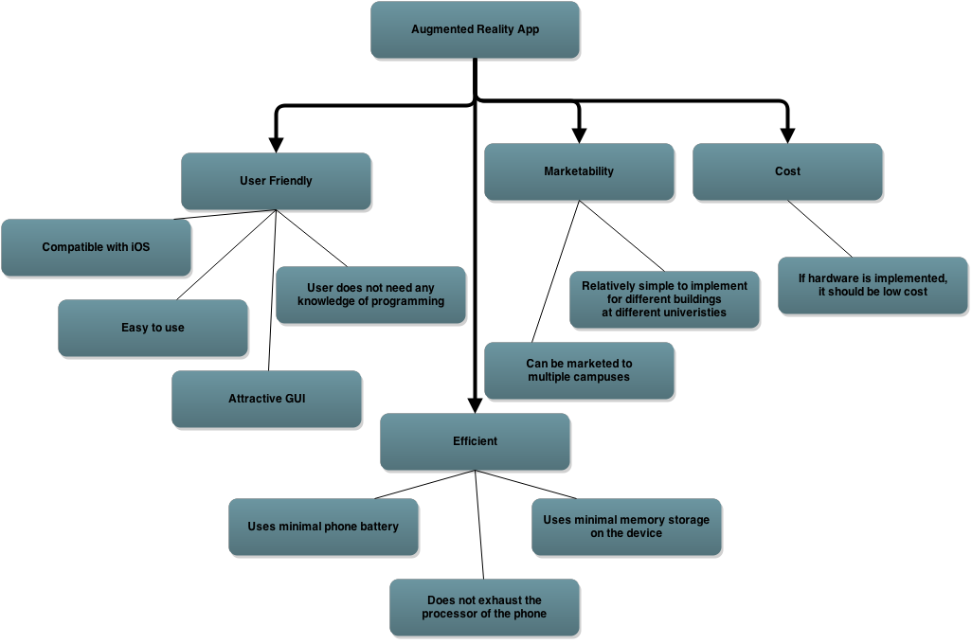

**Figure 1.2**

The objectives tree shown in Figure 1.2 denotes the 4 major objectives we are focusing on as we develop this project. The four are user friendliness, efficiency, marketability, and cost. User friendliness covers such basic things as compatibility with the underlying operating system, ease of use, GUI attractiveness, and a lack of a programming background requirement. Efficiency is based on a minimal use of battery power, processing power, or storage on the device. Marketability is defined by the marketability of it in different buildings and the simplicity of implementing such a change. Cost is defined as the hardware cost and a preference towards low cost hardware.

* 1. **Comparison Chart**

|  |  |  |  |  |  |
| --- | --- | --- | --- | --- | --- |
| **GOALS** | **USER FRIENDLY** | **EFFICIENCY** | **MARKETABILITY** | **COAST** | **SCORE** |
| USER FRIENDLY | X | 0 | 1 | 1 | 2 |
| EFFICIENCY | 0 | X | 1 | 1 | 2 |
| MARKETABILITY | -1 | -1 | X | -1 | -3 |
| COST | -1 | -1 | 1 | X | -1 |

Chart 1.3

-1: The goal in the row is less important than the goal in the column.

0: The goal in the row is equally important to the goal in the column.

1: The goal in the row is more important than the goal in the column.

x: Cannot compare goal relative to itself

The rows are the significant objective under consideration, while the columns are the comparison goals. The rows depict the specific characteristic that is being compared to the other main goals. Each row compares a particular goal to its relevance or overlap into other goals for the product. The goals of user friendly and efficiency both scored 2, showing that these two goals encompass multiple areas in the project. User friendliness is a goal that was emphasized by the client, and it encompasses the desired purpose for the product. Efficiency is the other desired objective for this app in order to convince our client that it will run smoothly on their phones. These two goals must be achieved in order to fulfill the needs for the product and meet the client’s expectations. The goals of marketability and cost are not as important because they scored -3 and -1 respectively. Even though they relate to some other areas, they are not as essential for the overall outcome of the product. Marketability and coast scored low because our main intention building this app is not to make money. Cost scored a little bit higher because as far as hardware implementation is involved, the cost will have to be considered. Overall, we will focus more on making the App user friendly and efficient, but we will also make sure that the coast for implementation is not high and it is marketable.

* 1. **Problem Definition**

Need:

When people first arrive at the engineering building, often they get confused and lost. This can make it difficult to arrive to classes on time and ready to learn. The building is naturally confusing with rooms and labels that don’t always make sense on the first arrival. This can be remedied through an app which makes maps and locations easily accessible to anyone. This app also should not simply be a map as those can be confusing and hard to interpret.

Objective:

The objective of this project is to create an augmented reality app which can be implemented to help people find their way around the engineering building. This can be used through a menu to select where they are going and then directions can be shown on the screen using the augmented reality format. The app should provide easy to use directions which tell students how to get where they need to go. The app should be user friendly and not require knowledge of programming to use. The key objectives of the app are obviously ease of use, efficiency, marketability, and cost. It should be easy to use, not taxing on the phone’s battery, storage, or processing capability, easily marketable and pleasing to viewers, and cost efficient for development and dispersion.